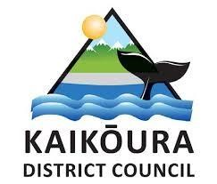
Update - Waiau Toa / Clarence River Bridge Project – 6 March 2024
As indicated in the previous update (22 November 2023) KDC encountered challenges in its application for resource consents in respect of the proposed new bridge downstream of the former bridge site. In particular the application was opposed by Te Runanga o Kaikōura.

Based on legal advice a decision has been made to put the consent application process on hold and to work with the preferred contractor (Concrete Structures Ltd) to further explore the feasibility of re-establishing access to the former Glen Alton bridge site by creating a road over Jacobs Hill. Local contractors have also been involved in this exploration.

Constructing a new bridge at the original site would have a number of advantages over the previously proposed downstream (‘Option 2’) site, including that Te Runanga o Kaikōura has now formally advised that they would support the construction of such a bridge, whilst they would continue to oppose a downstream bridge, making obtaining the required resource consents difficult.

It is however important to note that the construction of a new bridge at the original site is at this time still only a concept that is being explored further; it is not yet a proposal.

The re-construction of a bridge at the original site had been previously investigated by Beca consultants, who had indicated that it would be very substantially more expensive that constructing a bridge further downstream, and for that reason it had not been the preferred option of Council.

Constructing the bridge at the original site is only likely to become a proposal if it can be demonstrated that the cost of doing so (in respect of both initial construction and likely future maintenance) is more comparable with that of the downstream site, and a number of other associated issues (technical, financial and property) can be resolved.

Exploring the technical issues is the current focus of council. A geologist is undertaking a detailed survey of Jacobs Hill to assess the construction and stability of a road over it, and further investigation will be conducted of what protection from the river the upstream section of the new road would require.

Whilst before the 2016 earthquake a road had existed between the downstream spur of Jacob’s Hill and the former bridge site, it had done so without the river being adjacent to it, and previous work undertaken by Beca consultants had indicated that extensive (and expensive) erosion protection measures would now be required to protect this section of road from an extreme river flood.

If satisfactory and affordable solutions to these technical issues are now indicated to exist, property, funding and consenting issues would then be explored, and approval would be required from NZTA for any changes to project budgets or timelines.

Council is acutely aware that these further processes will create additional delays in a project for which progress has already been painfully slow but believes that there would be greater risk and potential delay by pushing forward with resource consent applications which may not be successful.

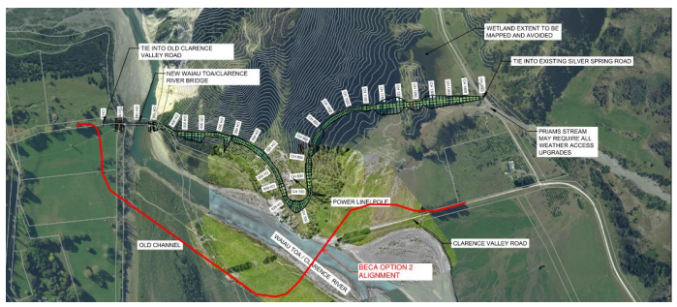
Beca proposed Option 2 road and bridge alignment (red) and a potential alternative alignment for new road connecting to original Glen Alton bridge site (concept only)

