Report to: | Council
Date: | - 5th August 2026
Subject: | Draft HeadStart Proposal
Prepared by: | - W Doughty - Chief Executive Officer
Input sought from: | P Kearney – Senior Manager Corporate Services
Authorised by: | W Doughty - Chief Executive Officer

PURPOSE
The purpose of this report is to seek high level feedback on the draft headstart proposal and to authorise the Mayor and CEO to work with our Marlborough District Council counterparts to finalise the joint proposal for submission to government. It is important to note that given the timeframes this is still a working draft proposal and will continue to be updated over the next week or so.

Attachments:
Attachment 1: Draft Head Start Proposal as of 30th July 2026 (to be circulated separately)
Attachment 2: DIA guidance on Head Start proposals.

Recommendation

It is recommended that the Council:
- Receives this report and the draft Head Start proposal.
- Provides high level feedback on the draft Head Start proposal noting some further changes have been made since the 30th July.
- Authorises the Mayor and the CEO to work with Marlborough District Council counterparts to finalise and submit the Headstart proposal.
- Notes the next steps and associated timelines.

background
On the 15th July elected members resolved the preferred option for submission of a head start proposal was a joint unitary Council with Marlborough District Council (MDC). At that time, MDC had not sought specific feedback from their community on an amalgamation option with Kaikōura District Council, but they subsequently ran a pulse survey between the 22nd and 29th July 2026 with 66% of the respondents supporting an amalgamation if key issues could be worked through. On the 30th July Marlborough District Council resolved to develop a joint Head Start proposal document with Kaikōura District Council, to inform its final decision next Thursday 6 August on whether or not to submit it to the Government.

Following the 15th July Council resolution the two Councils jointly requested an extension of time from central government as a result of the recent extreme weather and flood event. Central government has responded with a request that we continue to submit a near final draft by the 9th of August for their early consideration and feedback, and a final document is submitted as soon as possible after that but no later than the 28th August.

Given the tight timeframes, officers from both Councils have continued to meet to work through the key issues identified by both Councils as well as develop a draft Head Start proposal that aligns with the guidance released from government regarding the five assessment criteria (see Appendix 2). As previously identified any headstart proposal must clearly demonstrate how it can achieve the following five assessment criteria.

- Deliverability – must be workable in time for the October 2028 local elections
- Support for the planning system – aligns with RMA replacement and Regional Spatial Plans
- Simplification of governance – reduces duplication between regional and territorial councils
- Economies of Scale – larger entity delivers services more efficiently
- Maintenance of local voice – fair representation and identity preserved for communities

The Draft proposal
We believe that the draft Head Start proposal meets all the eligibility criteria and represents a compelling case for change for the government to support us moving to the detailed design stage. The below graphic outlines some of the reasons why this proposal stands out.

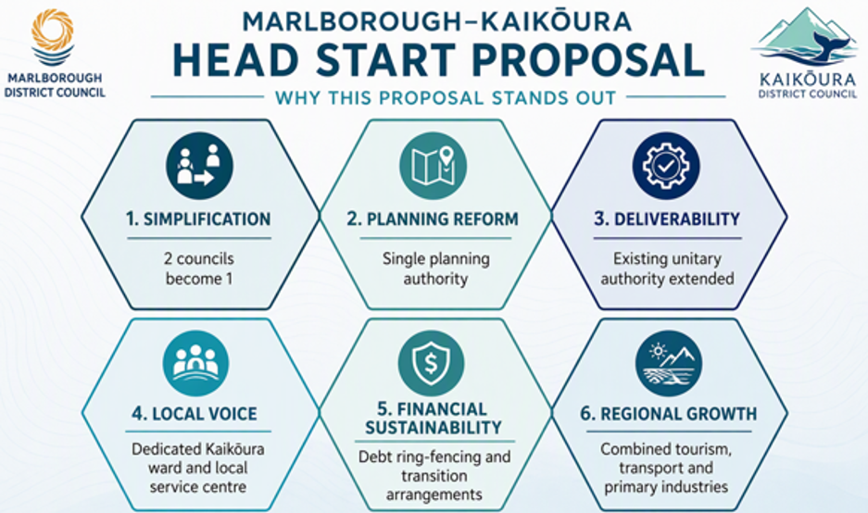

In terms of the draft proposal, we have outlined the case for change, the community and iwi engagement undertaken to date by both Councils, the key aspects of the proposal that have been discussed, and importantly the support that is required from government to help enable our proposal. We have then detailed eligibility under each of the assessment criteria as well as indicating mana whenua and treaty obligation considerations.

We have also outlined a clear transition pathway and next steps, separating these into the detailed design stage following government approval of our proposal and then implementation. We have attempted to signal indicative rough order magnitude cost estimates for the next stages and beyond. However, these would need to be refined once our proposal has been accepted. Finally, we have included a section regarding key strategic risks and opportunities, some of which have already been mitigated and others that will need further work through the detailed design stage.

It should be noted that this remains a draft document for feedback and will continue to evolve prior to submission on the 9th August based on feedback and any further information. As indicated, government has requested an advanced draft by the 9th August for their consideration and feedback, but we do have a further couple of weeks to finalise from there if rquired.

risks & financial implications
Despite the recent weather events, officers from both Councils have been able to advance further constructive conversations and develop a draft Head Start proposal. Governance level huis with local mana whenua have also been attended by both Councils to ensure we seek their feedback and input into the next steps for detailed design. Our head start proposal provides us with a good opportunity to front-foot change and to control our own destiny in terms of seeking positive long-term outcomes for both of our communities.

The most significant risk to Council remains if central government does not accept our joint Head Start proposal and therefore effectively placing us into the Back Stop process resulting in a loss of local influence and a reduced ability to secure outcomes aligned with the needs of the Kaikōura community (although what exactly the Backstop process is or how it will work is likely to remain unknown until May 2027). The level of ability for Council to influence the backstop process is very limited based on the current information.

A secondary risk is that central government delays their decision regarding approval of Head Start proposals until after the current election in November 2026. This will have implications for Kaikōura District Council in terms of the regional spatial planning work required to be undertaken under the new RMA legislation. We have clearly articulated in our proposal that should government accept our proposal to move to detailed design then Kaikōura would focus on alignment of the regional spatial planning work with Marlborough District Council rather than being part of a Canterbury based regional spatial planning exercise. We do not believe that split regional spatial plans for the new proposed unitary would be practical and workable.

In our Head Start proposal we have outlined a transition and implementation plan and have included key tasks and activities required for both the detailed design stage and implementation. The detailed design stage will include financial modelling to help define the longer-term financial implications of any reorganization. We have provided an indication of high-level cost estimates for both phases with the detailed design stage estimated at approximately $800,000 and implementation approximately $500,000. It should be noted that these are rough order magnitude costs at present and would need to be fully refined if the proposal is accepted by government. We are seeking government financial support with these costs as we do not want any long-term financial efficiencies from any amalgamation to be offset by transition costs. Consideration of how these costs will be jointly met needs to be given once we hear back from central government.

SIGNIFICANCE OF DECISION
This current decision is not considered significant in terms of Council’s Significance and Engagement Policy as at this stage it is seen as purely supporting a voluntary proposal rather than dictating an outcome. Further community consultation on specific issues will be undertaken through the detailed design stage.

RELEVANT LEGISLATION

At present, the government is seeking voluntary proposals that do not represent legislation. It is currently anticipated than in 2027, the reform programme will be supported by new legislation that enables local government reorganisation and establishes transitional arrangements. Council must ensure that any proposal aligns with this framework and with the broader intent of simplifying governance and improving regional coordination.

Council also currently remains subject to the Local Government Act 2002, including the requirement to apply consultation principles when making decisions of this nature. While timeframes limit the extent of formal consultation prior to submission, Council has undertaken initial engagement and will continue to incorporate community views into its decision-making. It is anticipated that there will be further opportunity to undertake further engagement and consultation with the community as the process evolves, but this will be depended on government legislation in 2027.

NEXT STEPS
As previously indicated, the graphic below outlines the current timeline for the reform agenda and upcoming key milestones. Following feedback from elected members, , we will continue to develop the draft proposal for submission by the 9th August and finalising as soon as possible after that.

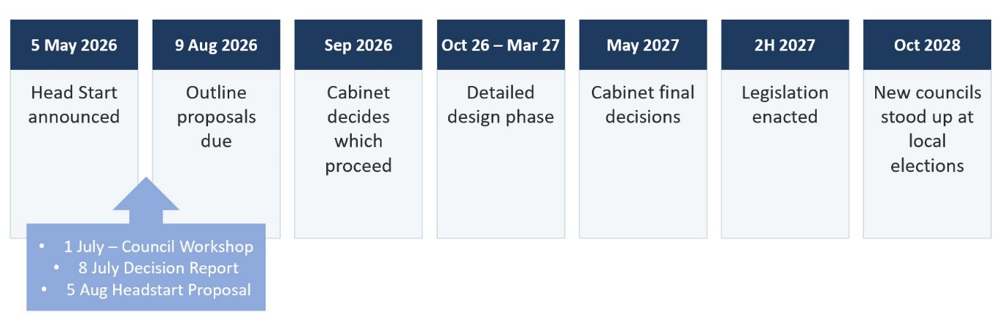

Community outcomes supported
The work is in support of all community outcomes.

 | Community  We communicate, engage and inform our community |  | Environment  We value and protect our environment
 | Development  We promote and support the development of our economy |  | Future  We work with our community and our partners to create a better place for future generations
 | Services  Our services and infrastructure are cost effective, efficient and fit-for-purpose

